SVCR GOVERNMENT DEGREE COLLEGE, PALAMANER
IQAC – STUDENT’S FEED BACK ON TEACHERS 2025 – 26
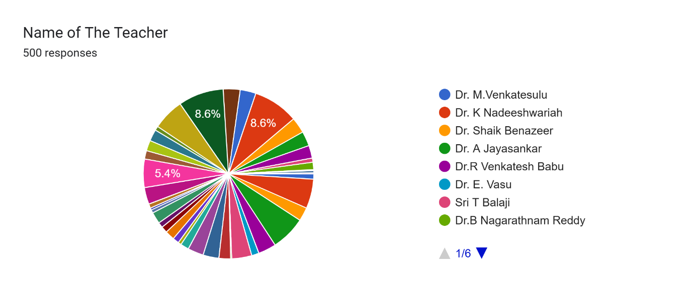
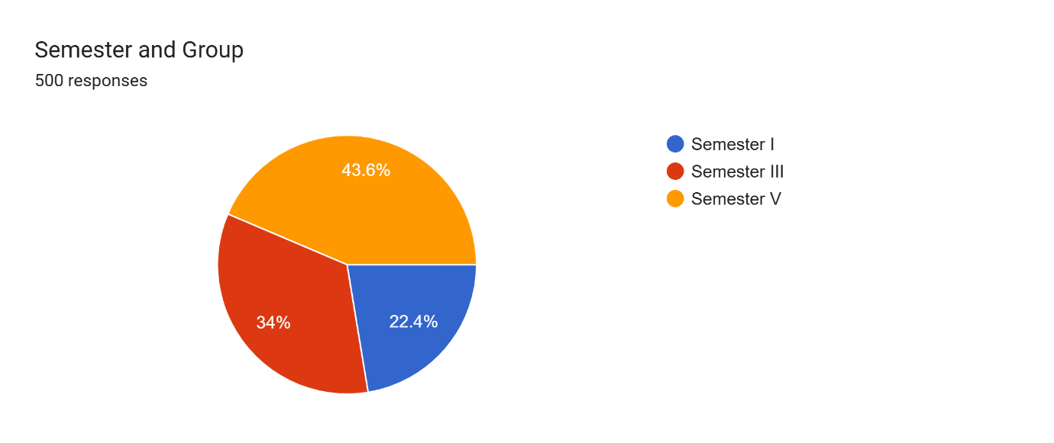
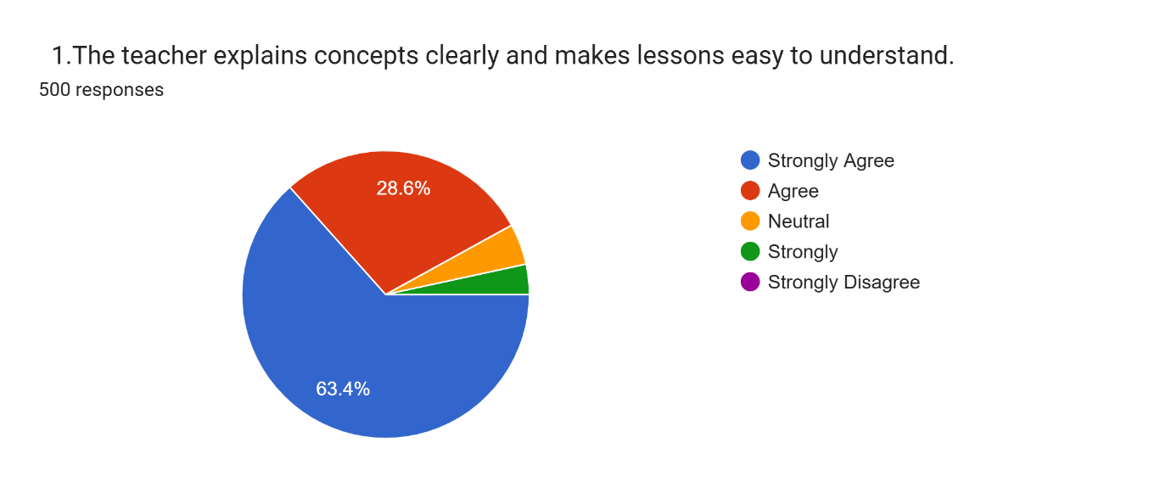
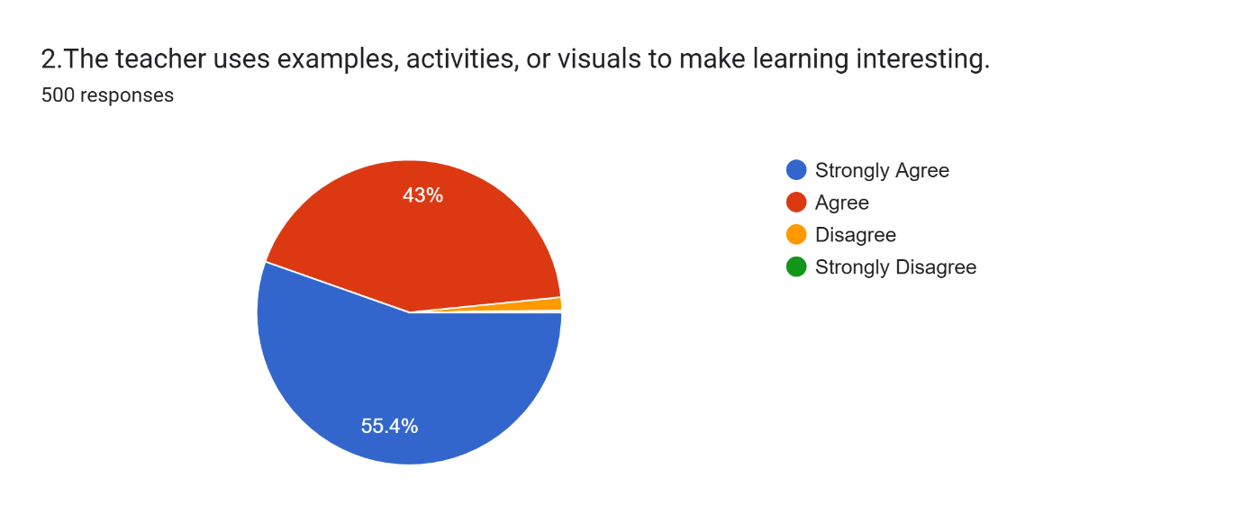
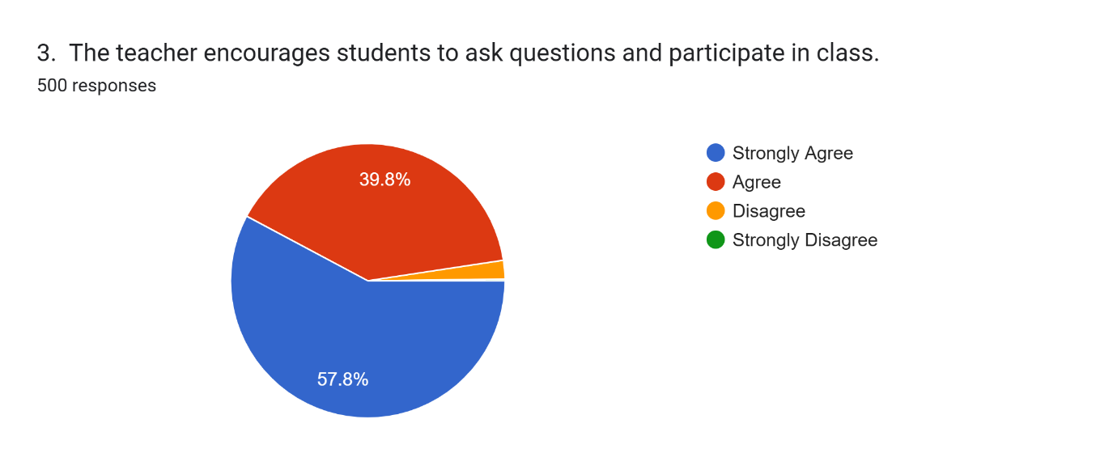
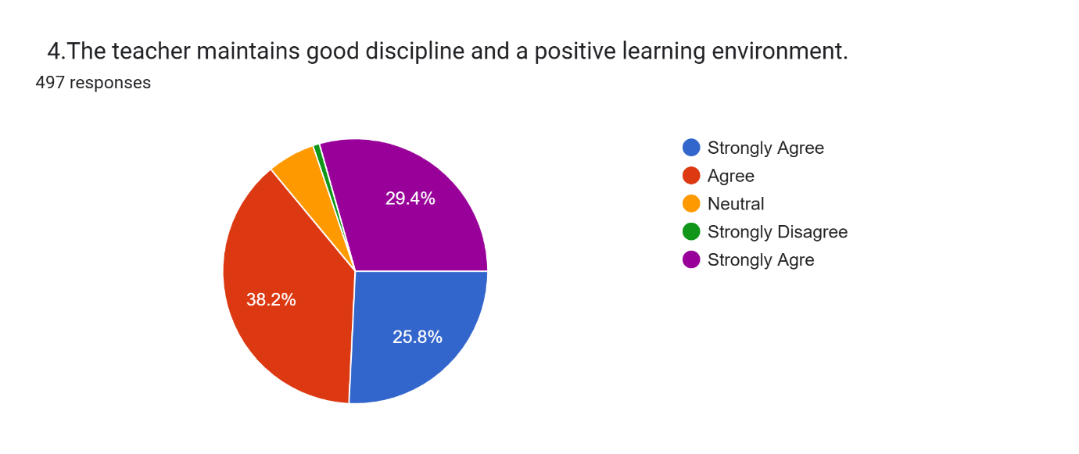
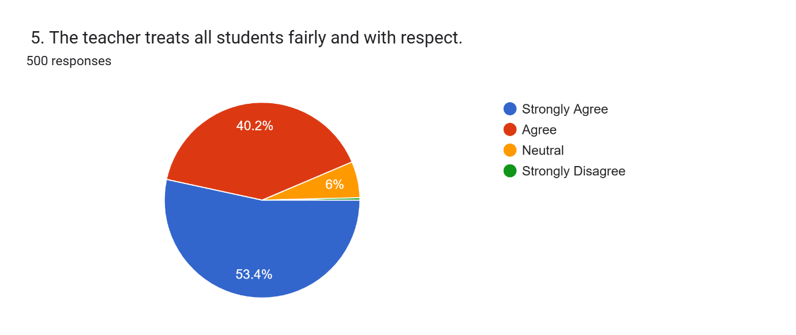
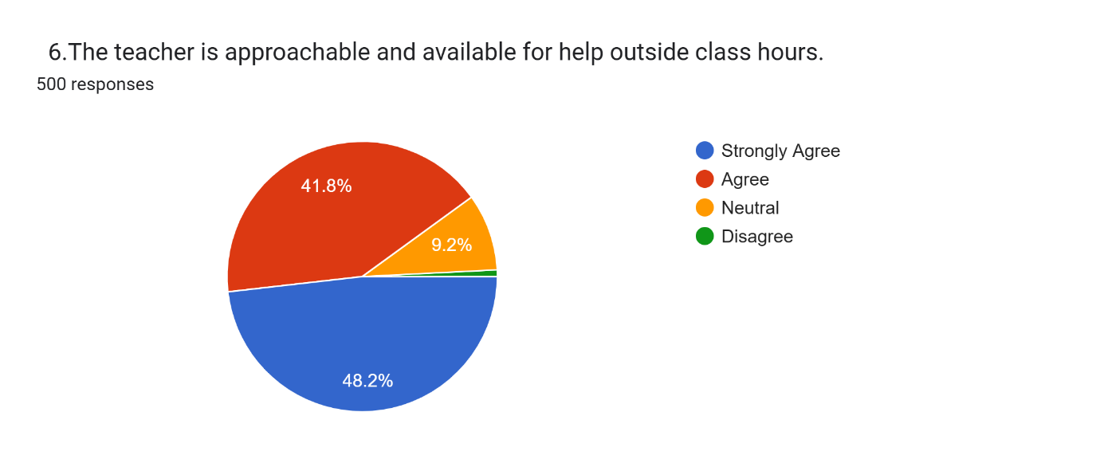
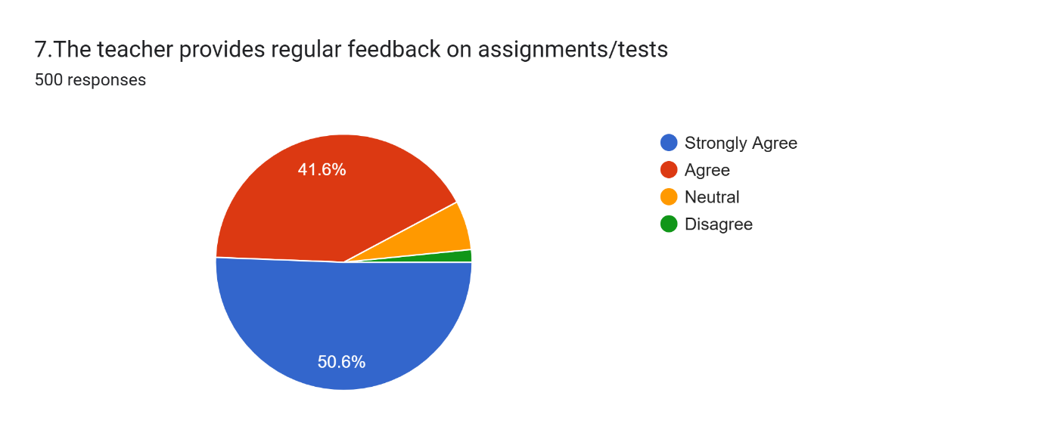
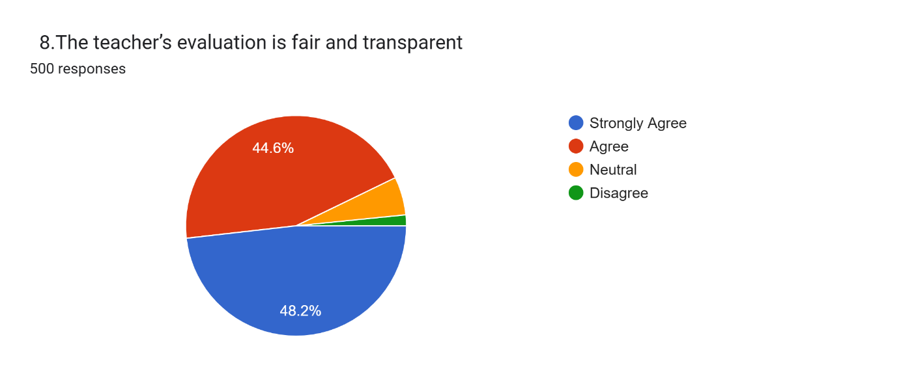
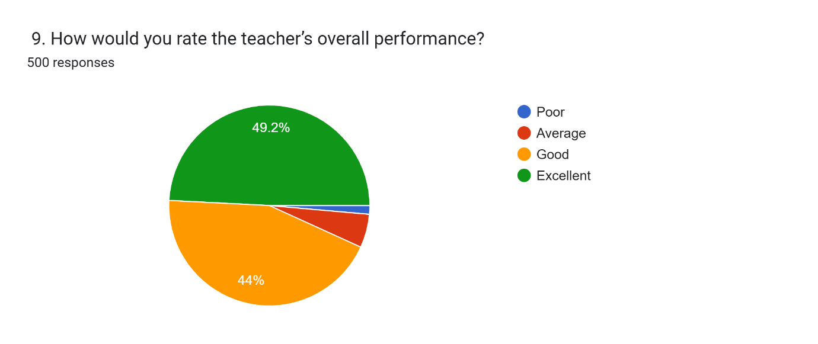
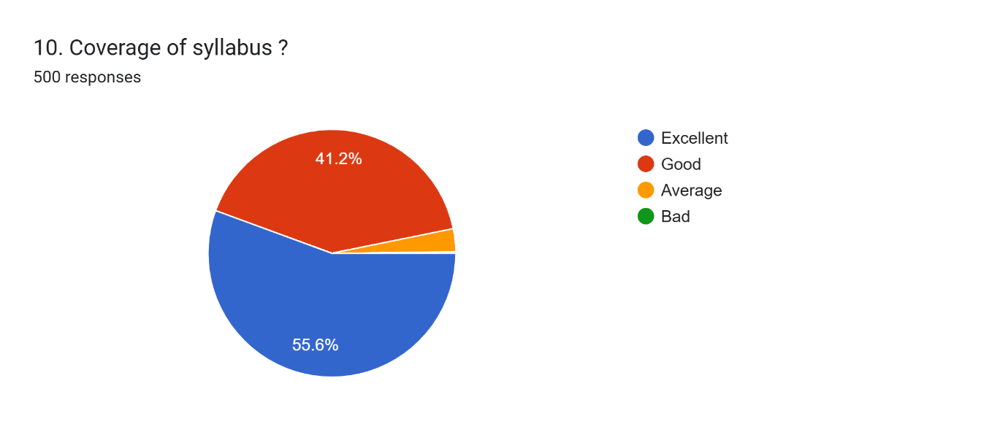

Student Feedback Analysis Report
Total Responses: 500
This report summarizes the collective feedback for various faculty members across Semesters I, III, and V. The data indicates a high level of student satisfaction regarding teaching clarity, engagement, and fairness.

1. Demographic Overview
- Respondent Distribution: The majority of respondents belong to Semester V (43.6%), followed by Semester III (34%), and Semester I (22.4%), indicating higher participation from senior students.
- Faculty Coverage: The survey covers all lecturers working under the supervision of the Principal, Dr. M. Venkatesulu.

2. Teaching Effectiveness & Classroom Engagement
The faculty scored exceptionally well in core pedagogical areas:
Metric | Strongly Agree | Agree | Key Takeaway
Concept Clarity | 63.4% | 28.6% | Over 90% find lessons easy to understand.
Use of Visuals/Activities | 55.4% | 43% | High success in making learning interesting.
Encouraging Participation | 57.8% | 39.8% | Students feel empowered to ask questions.

3. Learning Environment & Professionalism
The feedback highlights a respectful and disciplined atmosphere, though "Discipline" shows a more varied sentiment compared to other metrics.
- Fairness and Respect: 93.6% of students agree or strongly agree that they are treated with respect and fairness.
- Discipline & Environment: While generally positive, this metric has a significant "Neutral" and "Strongly Agree" split (referencing the purple/blue/red segments in Chart 4), suggesting slight variations in classroom management styles across different teachers.

4. Support and Evaluation
Students feel well-supported both during and after official class hours.
- Approachability: 90% of students agree that teachers are available for help outside of class.
- Feedback & Transparency: * 92.2% agree that feedback on tests/assignments is regular.
  - 92.8% agree that the evaluation process is fair and transparent.

5. Summary of Findings
Overall, the feedback reflects a highly positive perception of the teaching staff, who are regarded as clear in their instruction, approachable in their interactions, and fair in their evaluation. Concept Clarity (63.4% Strongly Agree), emerges as the strongest area, with a significant proportion of students expressing strong agreement. Discipline Management, while still viewed positively, shows a comparatively wider range of responses, indicating some scope for further consistency and alignment.

